Hello, and thank you for your interest in Minsthorpe Data Products:

At present we offer three products under the member’s area although we expect to expand this throughout 2018/19:

KS4: APA Pro:
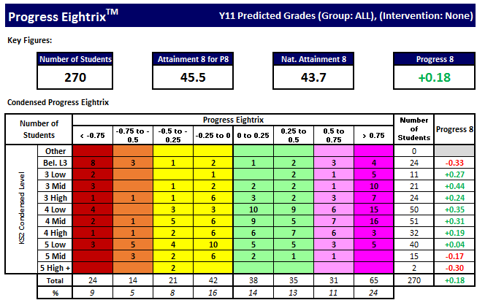
- Subject, Class & Group analysis using Progress 8 methodology

- Clear, single page summaries

- Suitable for class teachers through to leadership

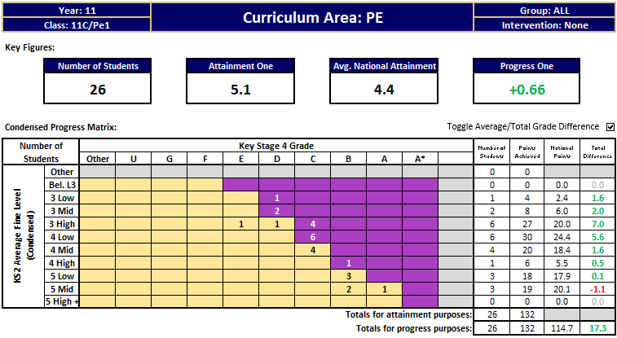

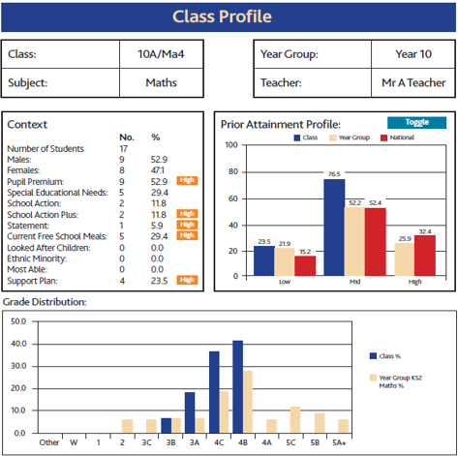
Class Profile:

- Context of The Class
- Class Targets based on
National
- Seating Plan Creation

KS5: APA Pro:
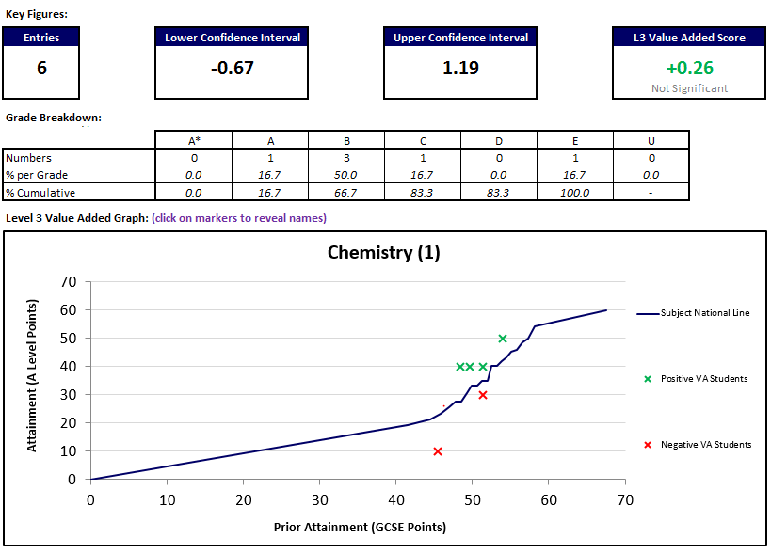
- Using L3VA methodology

- Subject and group performance analysis

